**Problem Statement:**

You work for XYZ Corporation. Your team is asked to deploy similar architecture multiple times for testing, development, and production purposes.Implement CloudFormation for the tasks assigned to you below.

**Tasks To Be Performed:**

1. Create a FIFO SQS queue and test by sending messages.

2. Register your mail in SES and send a test mail to yourself.

Create a SQS FIFO queue

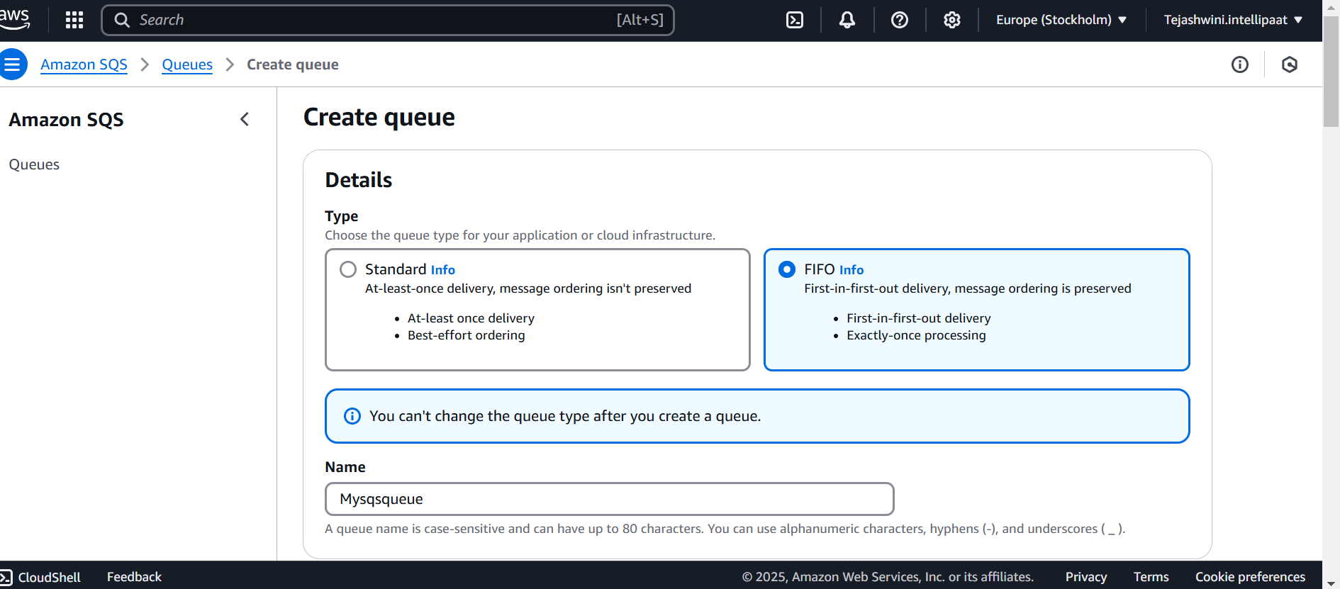

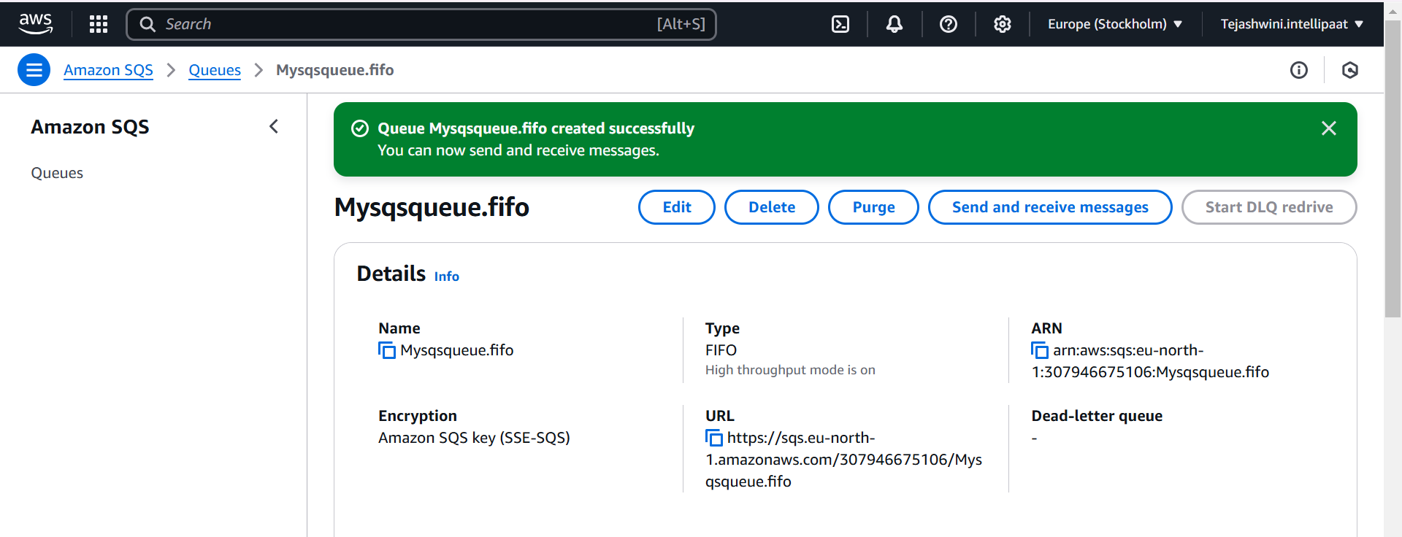

Test by sending the messages

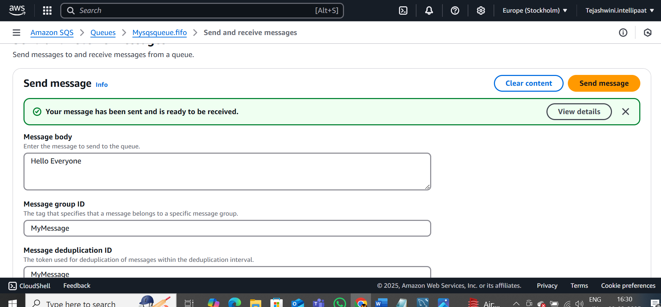

Poll for messages to check the received messages

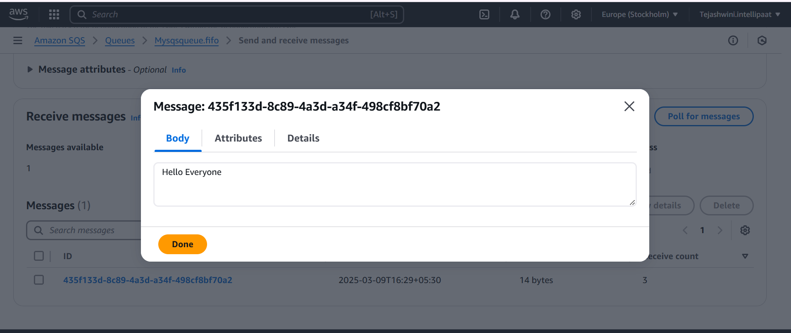

Create a SNS topic and subscribe to SNS topic ARN

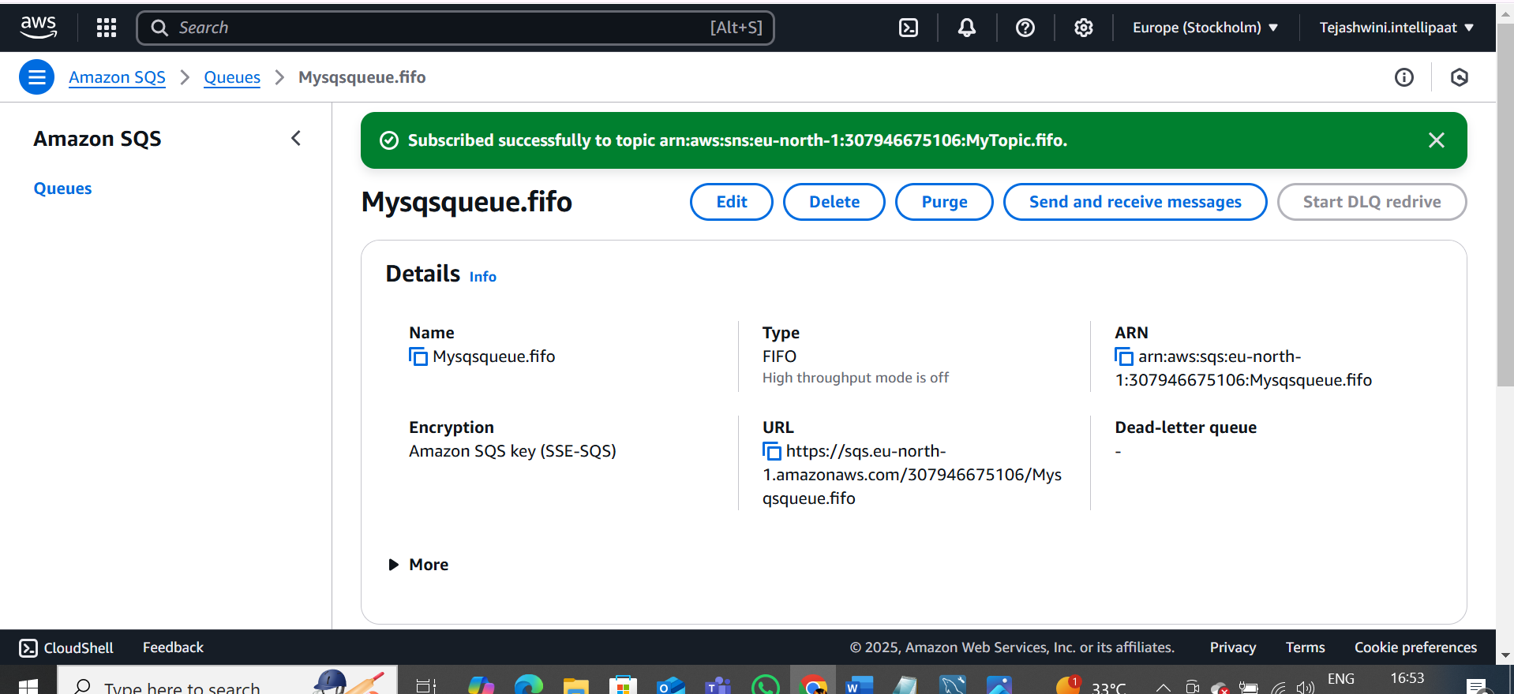

Go to SES service and create identity and register your mail ID

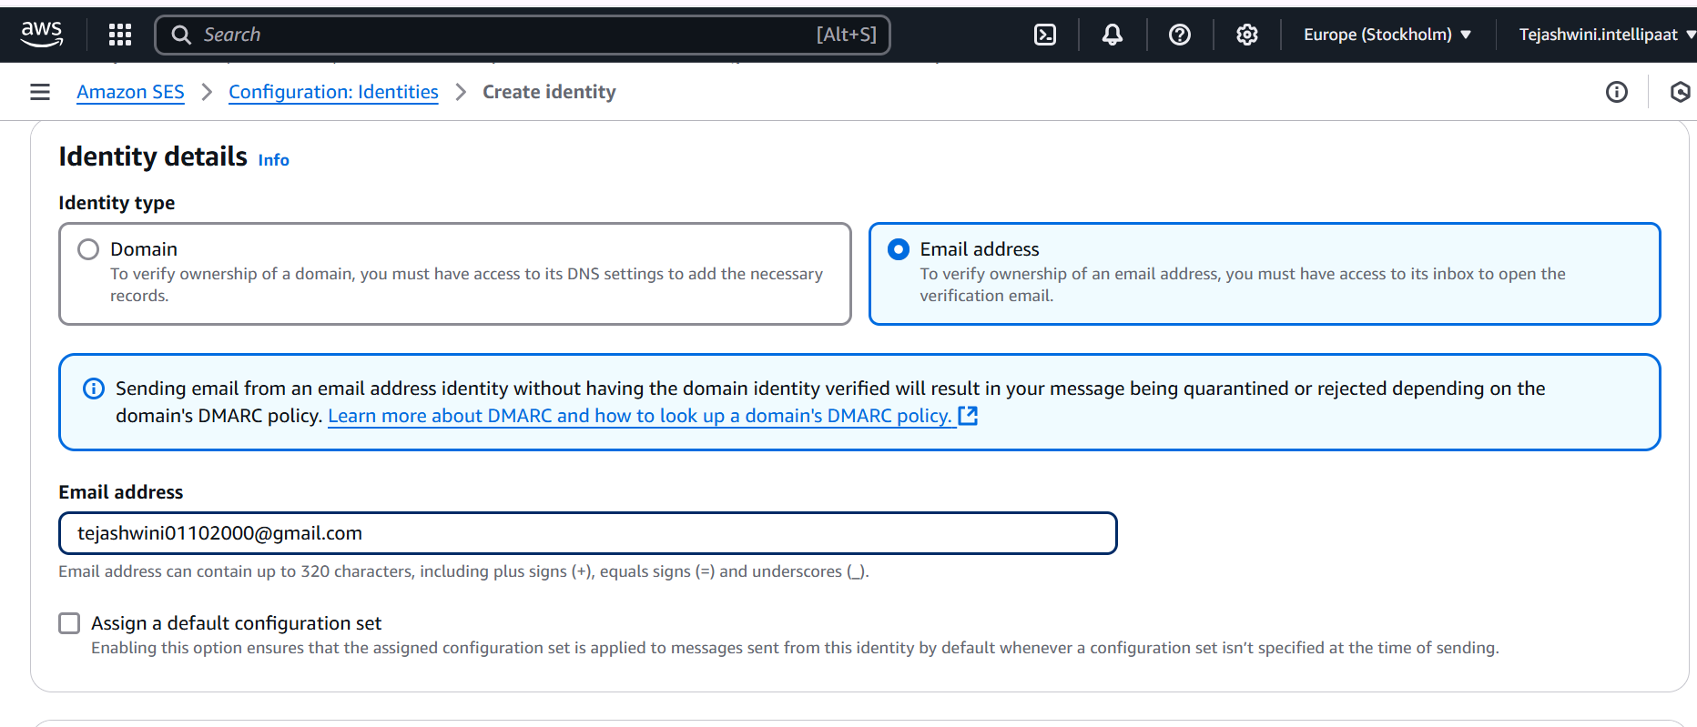

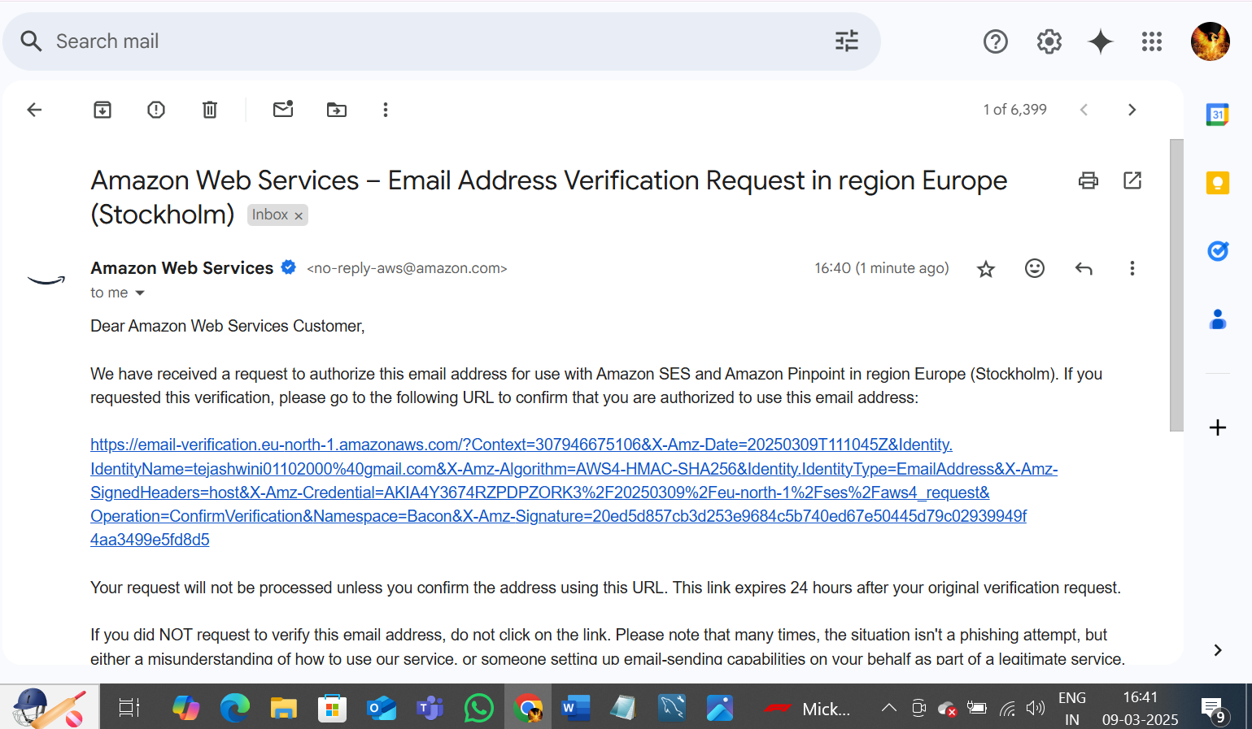

Test mail to your self

